Instruction Manual
for
MSim3V_IA

MSim3V_IA is a self-contained computer program that is designed to aid in the development of materials that accurately simulate the x-ray interaction properties of a user-specified target material. The overall scheme for tissue simulation that underlies this program and the other programs in the material simulation suite, along with descriptions of the algorithms used, are described in ref. 1. The version of the program in this set is written in FORTRAN. A somewhat more basic (fewer features) version written in C is also available. The current version of the program uses the data from the McMaster et al. compilation² to generate attenuation coefficients and their energy derivatives. Work is under way to convert the program to use data generated by the NIST program XCOM³.

Installation:

Installation is simple. Copy the files MSim3V_IA.exe and xraymu.dat to a folder of your choice. (If you received this package by email, the .exe file extension has probably been changed to .txt, to avoid being trapped by the FDA email filter. After you copy it, just change it back to .exe and it will run.) If you wish to use the plotting capability built into the program, copy the files PL1.txt, PL2.txt, and MSim3_Plt_Start.xls to the same directory. If you choose the folder C:\My Documents\MatSim, the plotting will work with no further intervention. You may choose any other folder, in which case it will be necessary to “teach” Excel and the .xls file to find the PL#.txt files. (See below). This is a straightforward procedure, and you only need to do it once. To uninstall any part of this package, simply delete it.

Running the Program:

MSim3V_IA.exe is a console application, and runs in a DOS window. You may launch the program by double clicking on the file. Windows will automatically open the window. Alternatively, you may use the COMMAND option to open the window and start the program by typing its name. If you choose this method, the complete path must be specified.

Input data: The program will ask you for information on the energy grid you wish to use, Emin, Emax, and delta E. It will then ask you for the ratio of the thickness of the composite material to that of the target material. The normal input value would be 1.0. Allowing the ratio to differ from 1.0 allows you to compensate for volume changes that may occur when components are mixed, or to design a material whose total attenuation coefficient is a constant fraction (greater or less than one) of the attenuation coefficient of the target material. Next, the program will ask for information on the target material and the three constituents you wish to try out for the simulation. The sequence of data requested is 1) name, 2) number of elements, 3) use mass fractions or formula units, pairs of Z and quantity (use mass fractions or formula units), and 4) density. If the constituent is a single element, density is not requested as it is available in the data file xraymu.dat. If you wish to specify a different density for a single element, tell the program that the constituent has two elements, and give the second one a quantity value of 0. Completion of data entry for the fourth constituent ends the data input sequence. Figure 1 is a screen shot (in two pieces) of the data input sequence for the simulation of 50 % glandular and 50 % adipose breast tissue using ethanol, glycol, and water over the energy range 10 to 60 keV with an energy step size of 1 keV.

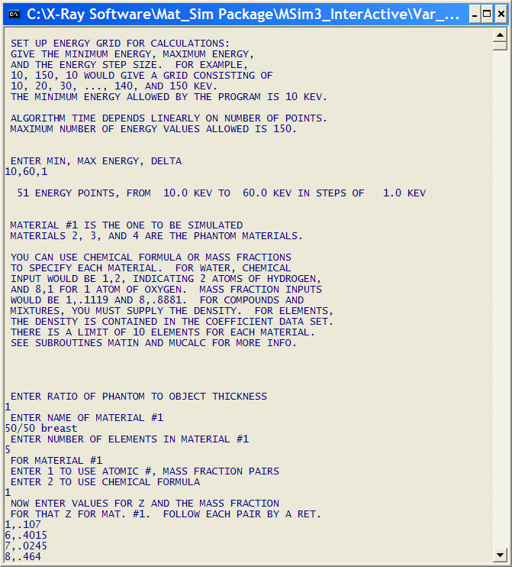

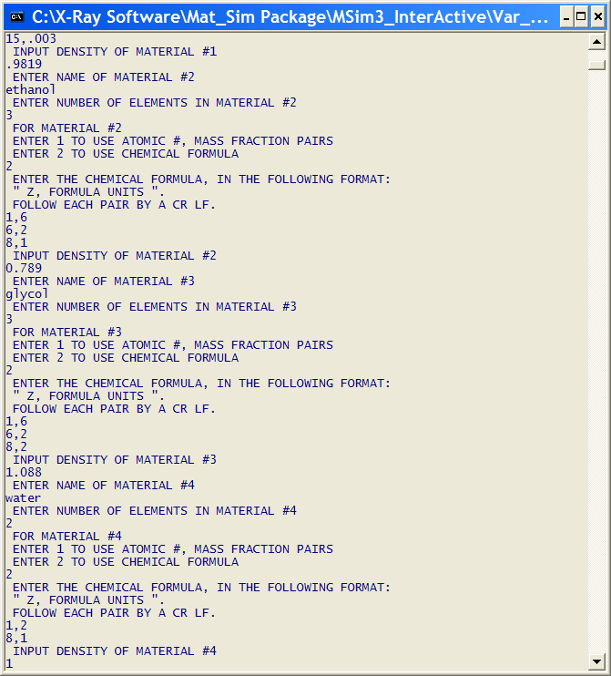

Figure 1

Program output: When all of the data have been entered, the program will compute the relative amounts of the three constituents to be used for the simulation that result in the best match to the target material, in a minimum-RMS-error sense, over the specified energy range. The program then writes to the screen a summary of relevant input and output data. Figure 2 is a screen shot of the output for the simulation described above.

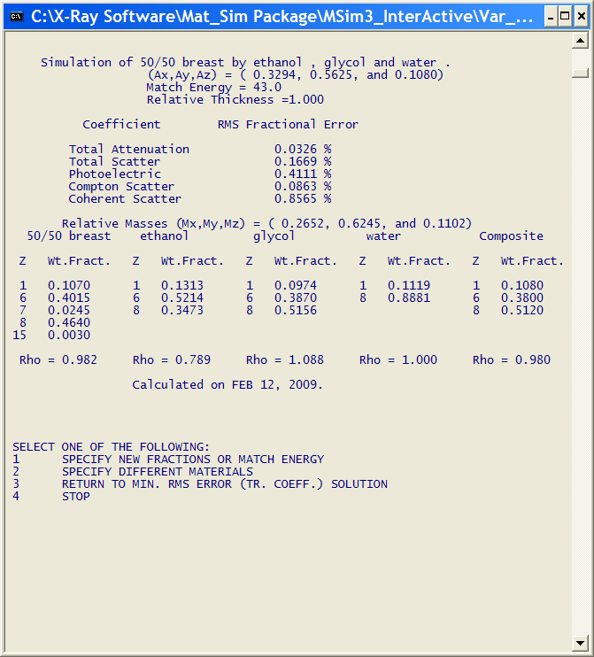

Figure 2

At this point, the work of the program might be considered over. To see how the results look in more detail, go to the section on plotting.

Other ways to use the program: After the initial calculation, the program offers the user some options. The output summary reports the energy for calculating the relative amounts of the three proposed constituents that produce the best match to the target material, Ematch. If you wish to force an exact match of total attenuation coefficients at a different energy, you may select option 1 and then specify the energy. If there are constraints on the problem that require specific proportions of the proposed constituents, these may be specified by selecting option 1, then -1 for fractions, then the fractions. To change the relative thickness of the simulation material relative to the target material, select option 1, then enter -2, then the relative thickness value. Enter 0 after any of these choices to return to the previous menu. Option 2 allows you to change any of the materials specified in the initial phase of the program.

Plotting the data:

Data files: As noted in the section on installation, the program produces two disk files, PL1.txt and PL2.txt. These are ASCII text files that can be read by programs such as Notepad and MS Word. The file PL1.txt has one line of text for every energy in the energy grid specified at the beginning of the program. Each line has three values, separated by spaces. The values are the x-ray energy in keV, the ratio of the total (or linear) attenuation coefficient of the composite material calculated by the program divided by the total coefficient of the material being simulated, and the same ratio for the total scatter coefficient. The total scatter coefficient is the sum of the incoherent (Compton) and coherent (Rayleigh) scatter coefficients. It is an ad hoc parameter that is used to give the user a rough idea of the relative match in overall scatter production between the substitute and the target material. The file PL2.txt has four values per line, x-ray energy, ratio of incoherent scatter coefficients, ratio of coherent scatter coefficients, and ratio of photoelectric coefficients. As in file PL1.txt, the ratios have the coefficient for the material being simulated in the denominator. Both files are opened with the “SHARED” attribute, so they can be accessed by another program while the program that created them (MSim3V_IA.exe) still has them open. The files are rewritten every time any of the simulation parameters is changed, so they are always up-to-date.

Excel file: MSim3_Plt_Start.xls is an Excel spread sheet file that was created to plot the data in files PL1.txt and PL2.txt. The spread sheet has two figures in addition to the columns of data from the input files. The upper figure is a graph with plots of total and total scatter coefficient ratios as functions of x-ray photon energy. The lower figure is a graph with plots of total, incoherent, coherent and photoelectric coefficient ratios as functions of x-ray energy. When you open the file, it will contain data from the last time it was opened. The spread sheet updates the input files once every minute, so the graphs change as the user changes the simulation parameters. If the input files have not changed, the graphs won’t either when the update occurs. If the regular update is not frequent enough, the user can force an update by clicking on the update icon in the tool bar at the top of the spread sheet. Figure 3 is a screen shot of the spread sheet window. The update icon is the Excel symbol with the orange exclamation point. If this icon does not appear, click in a data column of the spread sheet. The plots can be modified as you please. If you make changes, it is probably a good idea to save the spread sheet with a new name.

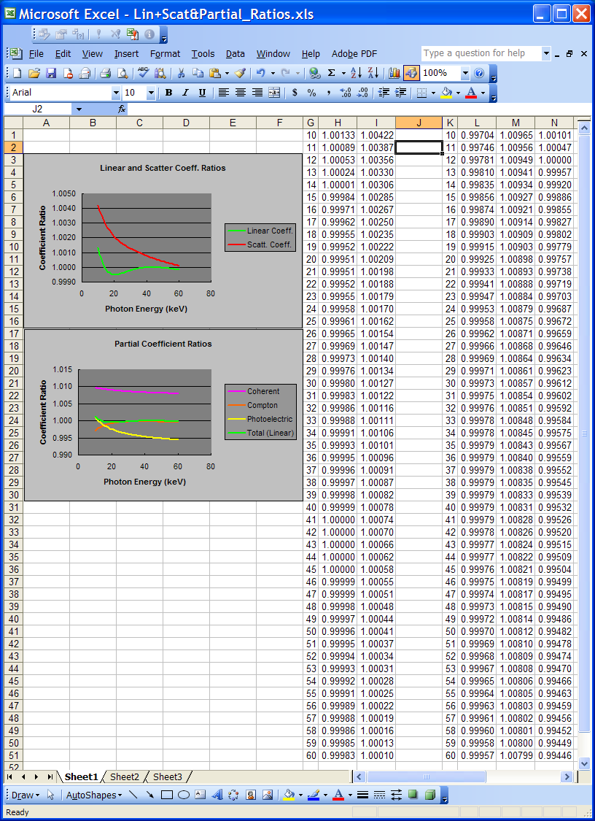

Figure 3

Training the Excel file to find the data: The spread sheet uses Excel’s Import External Data function, which retains the path to the data to be imported. If you have changed the location of the data files or the spread sheet, the retained path data will be incorrect. To fix this, click anywhere in the first 3 columns of data in the spread sheet (the data from PL1.txt), then click on the Data pull-down menu and select Import External Data. Next click on Edit Text Import. This action will bring up a window that allows you to browse to the location of PL1.txt. Repeat the process for PL2.txt. Once you have completed this process, the spread sheet will update correctly as long as the locations of the spread sheet and the data files remain unchanged.

References

1. Jennings, R.J., "Computational Methods for the Design of Test Objects and Tissue Substitutes for Radiologic Applications," Radiation Protection Dosimetry, 49 327-332, 1993.

2. McMaster, W. H., Del Grande, N. K., Mallett, J. H. and Hubbell, J. H., “Compilation of X-ray Cross Sections,” University of California, Lawrence Radiation Laboratory Report No. UCRL-50174 Sec. II Rev. 1 (NTIS-1969).

3. Berger, M.J., Hubbell, J.H., Seltzer, S.M., Chang, J., Coursey, J.S., Sukumar, R., Zucker, D.S., and Olsen, K. (2010), XCOM: Photon Cross Section Database (version 1.5). [Online] Available: http://physics.nist.gov/xcom [Saturday, 01-Dec-2012 23:25:15 EST]. National Institute of Standards and Technology, Gaithersburg, MD. Originally published as Berger, M.J. and Hubbell, J.H., "XCOM: Photon Cross Sections on a Personal Computer," NBSIR 87-3597, National Bureau of Standards (former name of NIST), Gaithersburg, MD (1987); and as Berger, M.J. and Hubbell, J.H., "NIST X-ray and Gamma-ray Attenuation Coefficients and Cross Sections Database," NIST Standard Reference Database 8, Version 2.0, National Institute of Standards and Technology, Gaithersburg, MD (1990).

